Become a corporate sponsor of …
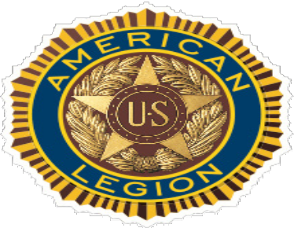The American Legion Department of Minnesota
State Convention and Fall Conference

Aid us in our missions:
- Helping our fellow veterans
- Strengthening our national defense
- Bolstering American ideals
- Engaging our community youth
These are done through programs that engage veterans and their families, our state and national legislative efforts, our work with the state and federal VA and more. It all culminates at our gatherings.

When are they:
- The Department Convention is July 12-15 at Jackpot Junction, Morton MN.

- The Department Fall Conference is Oct. 26-28. The location is St. Cloud Kelly Inn.

Select your level …
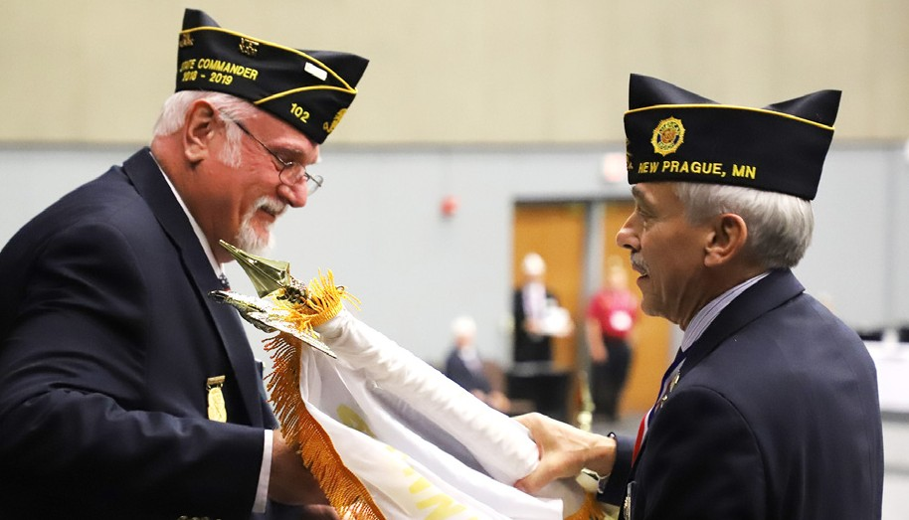
Star sponsor: $5,000: Title credit, booth location of choice, ad on back cover of program, only banner in hall, banner at registration desk, print and verbal acknowledgment Wreath sponsor: $2,500: Booth, full-page ad in program, banner at registration desk, print and verbal acknowledgement
Sunray sponsor: $1,000: Booth, full-page ad in program, print and verbal acknowledgement
Booth only: $200: Booth Donations are tax-deductible.

** Star, Wreath, and Sunray sponsorship is for both convention and fall conference. **

Name: Company: Address: City: State: Zip: Tel: Email:
Please make checks payable to “American Legion Department of Minnesota.” Send contributions to: Minnesota American Legion, 20 W. 12th St. Room 300A,
St. Paul, MN 55155. Call Tim at 651-424-4612 if you prefer to pay online via credit card.

