Issued in grateful appreciation for faithful and dedicated allegiance to the ideals of The American Legion. Be it known that

XX
a longtime and dedicated member of American Legion Post XX, Department of Minnesota has been certified to have been a member in good standing continuously for

XX
Years
And be it further known that such record of consistent loyalty to The American Legion merits the honor of being cited as an outstanding
contributor to the programs of The American Legion.
In witness thereof, this testimonial of personal gratitude is given under the hand of the National Commander, and duly attested by the National Adjutant, this 15th day of March, 2021.

Attest:

National Commander James W. “Bill” Oxford
National Adjutant Daniel S. Wheeler

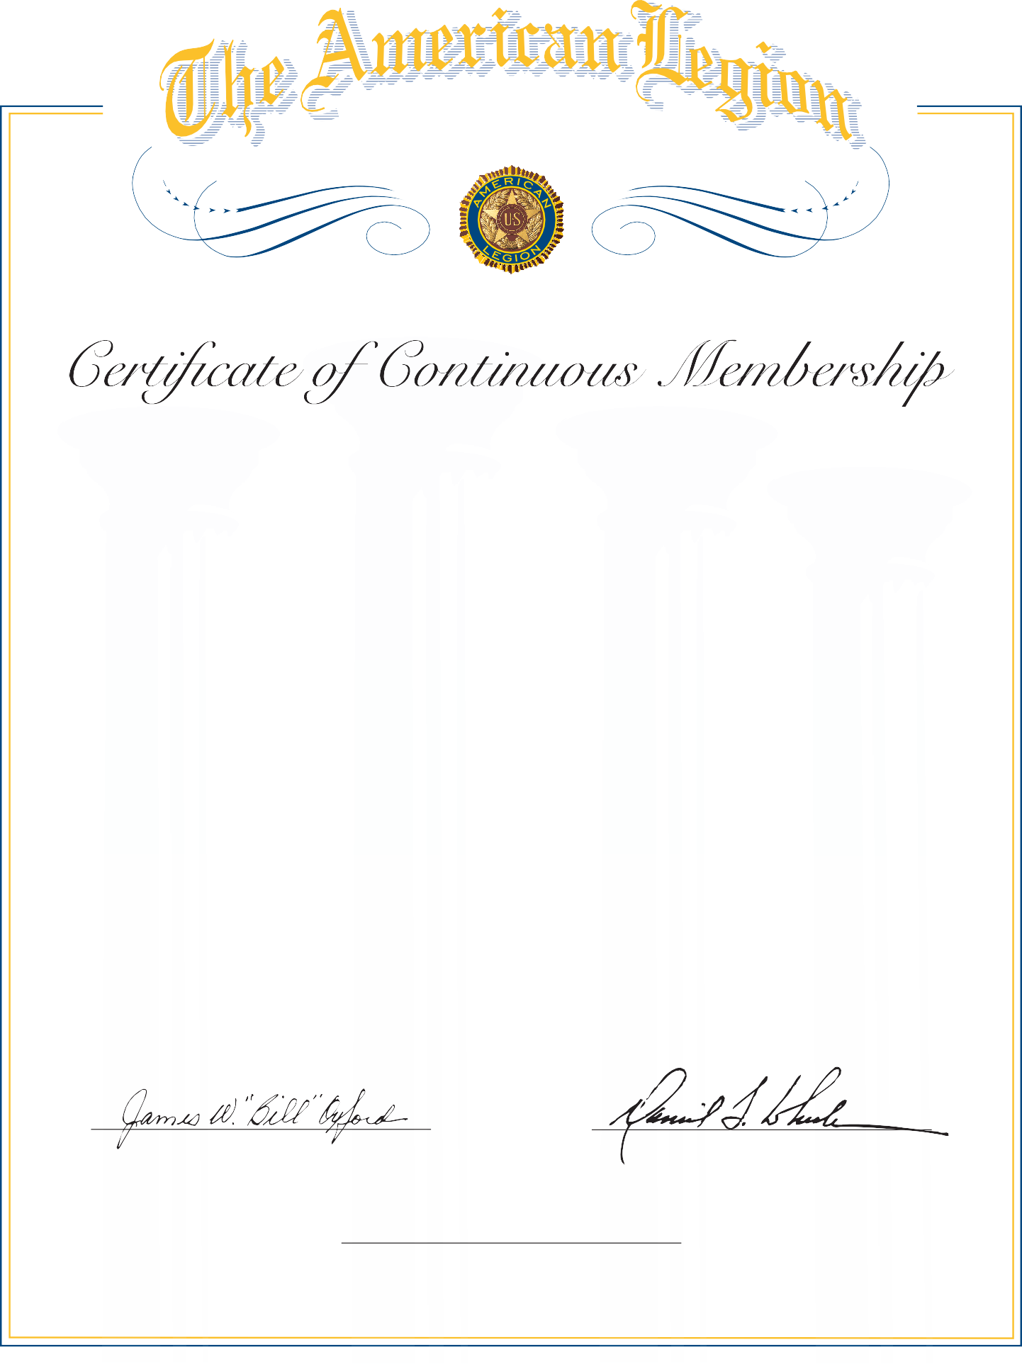

Post Officer

